Front page

# Project description

|  |  |
| --- | --- |
| **NTNU**  **Norges teknisk-naturvitenskapelige universitet** | **Fakultet for informasjonsteknologi, matematikk og elektroteknikk**  **Institutt for teknisk kybernetikk** |

**MASTEROPPGAVE**

Kandidatens navn: Morten Sletta-Heimdal

Fag: Teknisk kybernetikk

Oppgavens tittel: Maskinsyn for sanntids deteksjon av skader i oppdrettsnot

Engelsk tittel: Machine vision for real time detection of net damage in sea cages

Oppgavens tekst

Skader på noten i lakseoppdrettsanlegg medfører stor risiko for rømming, et problem som er assosiert med alvorlige økonomiske og miljømessige konsekvenser. I dag brukes dykkere til inspeksjon av noten, men denne aktiviteten kan være både risikofylt, tidkrevende og kostbar. ROV benyttes nå i økende grad som et alternativ til dykkerinspeksjon. Bakgrunnen for denne oppgaven er et ønske om å effektivisere ROV-operatørens arbeid med å inspisere noten og på sikt få automatisert denne arbeidskrevende og monotone operasjonen. Oppgaven tar sikte på å få utviklet robuste algoritmer med utgangspunkt i bildestrømmen fra ROVens kamera (eventuelt eget kamera og belysning) for sanntids deteksjon av skader og svakheter i noten. Oppgaven omfatter følgende punkter:

* Gjennomgang av problemstillingens bakgrunn, identifisering av forskjellige skadescenarier og utarbeidelse av kravspesifikasjon for deteksjonssystemet
* Kartlegging og diskusjon av faktorer som har innvirkning på bildekvaliteten i en typisk oppdrettsmerd, slik som kamerateknologi, belysning, dybdeavhengige lys- og kontrastforhold, fisk, turbiditet, og bølger.
* Gjøre en vurdering av kamerateknologi og belysningsutstyr på aktuell ROV (Argus) i forhold til systemets behov
* Design og utvikling av algoritmer for sanntids bildeanalyse av notpaneler og deteksjon av typiske tilfeller av notskader og -svakheter
* Planlegging og gjennomføring av tester av algoritmen(e) med hensyn til treffsikkerhet og robusthet, både under ideelle og realistiske betingelser
* Diskusjon av resultater og kartlegging av systemets muligheter og begrensninger

Oppgaven gitt: 16. januar 2013

Besvarelsen leveres innen: 12. juni 2013

Utført ved: Institutt for teknisk kybernetikk, NTNU

Veileder: Jo Arve Alfredsen, ITK, NTNU

Per Rundtop, SINTEF Fiskeri og Havbruk

Trondheim, 16. januar 2013

Jo Arve Alfredsen

Faglærer

# Preface

# Takk til

Jo Arve Alfredsen, ITK

Terje Haugen, ITK

Kevin Frank, Sintef

Per Rundtorp, Sintef

Trond Viggo Mellum, NRK

Rolf Hansen, Malvik Båtforening

Ole Sletta

Torild Sletta-Heimdal

Johannes Sletta-Heimdal



# Abstract

Contents

Project description i

Preface iii

Takk til iii

Abstract iv

List of figures viii

List of tables viii

Nomenclature viii

1. Introduction 1

2. Literature study 2

3. Theory 5

3.1. Color Spaces 5

3.1.1. CIE RGB 5

3.1.2. CIE XYZ 6

3.1.3. CIE xyY 7

3.1.4. CIE L*a*b 7

3.2. Segmentation methods 8

3.2.1. Naïve Thresholding 8

3.2.2. Adaptive thresholding 8

3.2.3. Otsu’s method 9

3.2.4. Using edge detection to enhance Otsu’s method 9

3.3. Net damage detection 9

3.4. Growth detection 10

4. Software design 11

4.1. Prototype 11

4.1.1. Color Spaces 12

4.1.2. Segmentation methods 12

4.1.2.1. Otsu’s metod 12

4.1.2.2. Using Sobel edge detection for segmentation 13

4.1.3. Net damage detection 14

4.1.4. Cross-correlation detection of net 14

4.1.5. Boundary tracing using shape number 15

4.2. System 1 18

4.2.1. Color Spaces 18

4.2.2. Segmentation Methods 19

4.2.3. Cage damage detection 20

4.2.4. Real Time Considerations 21

4.3. System 2 23

5. Testing and Results 24

5.1. Test set-up 24

5.1.1. Camera 24

5.1.2. HD-SDI interface module 24

5.1.3. Frame grabber 25

5.1.4. Camera housing 25

5.1.5. Lights 26

5.1.6. Camera problems 26

5.1.7. Sea-cage panels 27

5.1.8. Test Rig 28

5.2. Field test 28

5.3. Testing of captured video on System 1 30

5.3.1. Color spaces 31

5.3.2. Segmentation methods 31

5.3.3. Using Sobel for segmentation 32

5.3.3.1. Using Scharr for segmentation 32

5.3.3.2. Using Otsu’s method for segmentation 33

5.3.4. Using naïve thresholding for segmentation 34

5.3.5. Adaptive thresholding 34

5.3.6. Improvements to be made on System 1 36

5.4. Testing of captured video on System 2 37

5.4.1. Sea-cage panel with hole 38

5.4.2. Sea-cage panel with growth 38

5.4.3. Sea-cage panel with vertical tear 38

5.4.4. Sea-cage panel with horizontal tear 38

5.4.5. Sea-cage panel with L shaped tear 38

5.4.6. Sea-cage panel with double netting 38

Discussion 38

Conclusion 39

Future work 40

Reference list i

Appendices ii

Appendix A – Color space images ii

Prototype color spaces ii

Appendix B – Sony FCB-H11 vi

Appendix C – iShot FCB HD-SDI INTERFACE MODULE viii

# List of figures

Figure 1: Principal schematic sea cage (Akvaplan-niva AS, 2005) 2

Figure 2: Development of a tear due to too much load on the side-rope (green) (Akvaplan-niva AS, 2005) 3

Figure 3: L-tear in sea cage (Heide & Moe, 2004) 4

Figure 4: Eye cone response curve (Kerr, 2010) 5

Figure 5: CIE RGB color matching functions (Kerr, 2010) 6

Figure 6: CIE XYZ color matching functions (Kerr, 2010) 7

Figure 7: CIE L*a*b* (HunterLab, 2008) 8

Figure 8: Poor quality image with hole (top). Output from program (bottom) with the found suspecting area (left) and its corresponding area in the input image (right) 12

Figure 9: Image used for testing Otsu's method 12

Figure 10: Thresholded image using Otsu's method (left) and using Otsu's method on sub-images (right) 13

Figure 11: Global Otsu's method (left) and Otsu's method on sub-images (right) 13

Figure 12: Otsu's method using dilation, thinning, and spurring. Red color space (left) and Y color space (right) 13

Figure 13: Foreground and background using segmentation with edge detection. Image dilated before thinning and spurring (left) and image not dilated (right) 14

Figure 14: Input to region growing algorithm (left), output from region growing (right) 14

Figure 15: Biggest suspect region (left) and the same area in the original image (right) 14

Figure 16: System 1 18

Figure 17: Luminance images, L(left) and Y(right) 19

Figure 18: Global Sobel segmentation parameters 19

Figure 19: Local Sobel segmentation parameters 19

Figure 20: Global Scharr segmentation parameters (left) and Local Scharr segmentation parameters (right) 20

Figure 21: Local Otsu segmentation parameters 20

Figure 22: Simple Thresholding segmentation parameters 20

Figure 23: Adaptive Thresholding segmentation parameters 20

Figure 24: Example image after region growing 21

Figure 25: Run time for loading in image and using self-written XYZ transformation using .at(left) or OpenCV’s XYZ transformation(right) 21

Figure 26: Run time for loading image and using self-written XYZ transformation using pointers 22

Figure 27: Loading in image and using OpenCVs L*a*b transformation, extracting L 22

Figure 28: Y and global Sobel(left), Y and local sobel with 5 subimages(right) 23

Figure 29: Y and Global Scharr(left), Y and local Scharr with 5 subimages(right) 23

Figure 30: Y nad global Otsu(left), Y and local Otsu with 5 subimages(right), Y and local otsu with 40 subimages (bottom) 23

# List of tables

# Nomenclature

4-connectivity –

Additive color space – A color space where a color is described by the amount of the three primaries needed to combined make that color.

CIE – International Commission on Illumination

GUI – Graphical user interface

IDE – Integrated development environment

# Introduction

Ll

# Literature study



Figure 1: Principal schematic sea cage (Akvaplan-niva AS, 2005)

The escaping of fish is a large problem in the aquaculture industry. Not only is the loss of fish a direct loss in form of money but there is also the problem of the farmed fish mating with the wild fish. This leads to the degeneration of the wild fish genetic material. According to (Rønning, 2011) and (Klima- og forurensningsdirektoratet, 2012) the problem is that the farmed salmon is bred based on criteria’s such as the ability to grow fast, fat content, flesh color and disease resistance. The qualities needed to survive in the wild however are quite different and more varied. A salmon that has a genetic material closer to the farmed salmon will not be as resistant to changes in its environment. Also the smolt production have been found in controlled experiments to be 30% lower for escaped farmed salmon compared to wild salmon. If the wild salmon gets a decreased smolt production and weaker genetic material the damages to the wild salmon population may be irreversible.

Another problem that comes from escaped farmed fish is diseases, and in particular the *Lepeophteirus salmonis* lice. According to (Direktoratet for naturforvaltning, 2012), *Lepeophteirus salmonis* is a crustacean that attack salmon, sea trout and char. It is a severe threat to the wild salmon, and in some areas it threatens to eradicate the wild salmon and sea trout population. With the huge increase in overall fish numbers due to fish farming the lice population have also increased. The lice release its eggs into the water where the eggs develop into larvae that follow the current and attack wild salmon and sea trout. As few as 9 to 11 lice is considered deadly for the young salmon that comes from the rivers and are entering the sea. In the fish farming facilities the lice population is kept down with chemicals and wrasse. There is a concern that the lice are getting resistant to the chemicals that are used and the fish farms thereby losing their means to combat this threat.

In (Jensen, Dempster, Thorstad, Uglem, & Fredheim, 2010) many interesting numbers about aquaculture in Norway can be found. In Norway 3.93 million salmon and 0.98 million rainbow trout escaped in the span 2001-2009, while 1.05 million cod escaped in the span 2004-2009. This seems a lot but as an example there was at any given time in 2009 approximately 310 million Atlantic salmon and rainbow trout in sea cages in Norway. It seems that cod is especially hard to prevent from escaping. While the salmon escapes mainly after structural failures of containment equipment the cod escapes more often through holes in the net. The cod also bites on the net and thereby makes holes from which it escapes.

In (Taylor & Kelly, 2010) escaped incidents in Scottish aquaculture are reviewed. In Scottish aquaculture the most common cause of escape incidents is due to holes in the net. Of the reported incidents from May 2002 to October 2009, 57% of the incidents were due to holes in the net, which led to a total of 700.359 escaped fish. Incidents caused by predation and chafe/snag are the two most frequently occurring causes for holes in the net.

The sea cages being used are either square cages with 20 to 40m sides which are 35 m deep, or circular cages with a circumference of 90-157m that are 15-48m deep. Total cage volumes range from 20.000 to 80.000 $m^{3}$ (Jensen, Dempster, Thorstad, Uglem, & Fredheim, 2010).

In the sea cage there can be tears due to local overload when raising the cage net. From (Akvaplan-niva AS, 2005) it is stated that tearing of the net during handling is a big source for escape incidents. In Figure 2 how a tear may develop due to wrong handling is shown.

 

Figure 2: Development of a tear due to too much load on the side-rope (green) (Akvaplan-niva AS, 2005)

According to (Heide & Moe, 2004) the worst kind of tear is the L tear as shown in Figure 3. With a tear like this the fish have a high probability to find a way out of the sea cage. Horizontal tears can also make gaping holes that the fish can escape through while vertical tears don’t make gaping holes so the fish is least likely to escape through a vertical tear.



Figure 3: L-tear in sea cage (Heide & Moe, 2004)

To inspect the cage net divers can be used for visual inspection. Divers can also perform tasks such as removing dead fish, report on the fish condition and inspect moorings. The divers can identify net damage before the damage leads to escape incidents. ROVs can also be used to inspect the sea cage as well as performing cleaning operations. In the future there is hope that the ROV can automatically detect and repair holes. Many different approaches are possible to do this detection. In (Taylor & Kelly, 2010) they recommend that research should be undertaken into devices that could detect holes in the net. However they stated that cameras have been found difficult to use for this task.

There are not only holes in the net that can be detected using computer vision. A major concern for fish farmers is growths on the net that disturbs the water flow through the sea cage. Seeing the progress of growths on the net can help the fish farmers to better control when net cleaning should be performed. One threat for the fish is a little hydroid named *Ectopleura larynx.* This little creature and how to combat it have been the focal point in (Guenther, Fitridge, & Misimi, 2011). According to this report biofouling is a serious problem for fish farmers. It has a negative impact on the water exchange across the net and the water quality within the cages. It also can lead to cage deformation and structural fatigue. To remove the organism the sea cages are cleaned with high pressure salt water, this method removes most of the hydroids. However by removing them from one contaminated net the *E.larynx* concentration in the water surrounding the nets increases and the hydroids loosened from one net may settle on another net.

# Theory

Background theory of some of the important algorithms and methods used

## Color Spaces

The first thing to do with an image is to determine the color space to use. There are different reasons for doing this.

* One reason is that when obtaining color images the images generally have three channels of color information, for example red, green and blue (RGB). Processing all the pixels in an image over all three channels adds computing time that may make the system to not work in real time. If it is possible to use single or double channel color spaces that obtain all the information needed this can reduce computational time significantly.
* Another reason to use different color spaces is to use the color space that gives the maximum amount of information for the rest of the system. This can make operations like segmentation and subsequently damage detection easier.

From (Kerr, 2010) it is stated that when the eye perceives color tiny elements of what we see is observed on the retina which has three kinds of cones. Each cone reacts differently to light at each wavelength. When an area of the retina is bathed in light the spectrum of the light on each cone is multiplied by the cones spectral response. The three products are then added together to give the output from the cone. The eye cone response curve can be seen in Figure 4.



Figure 4: Eye cone response curve (Kerr, 2010)

### CIE RGB

To characterize the response of the human eye a series of experiments were performed in 1931. The basic experiment used a small screen where one half of the screen had the light of a test color while the other half was made up of a composition of three primaries. The primaries had spectrums consisting of only a single wave length. The test person adjusted the three primaries to match the test light. The value of the ormaries was recorded and another test light shown. Using this method with multiple observers they accumulated a vast amount of data.

In Figure 5 functions for the primaries which is shown. Here the amounts of each primary color that are needed to make a specific color wave-length are shown. While they are not equivalent of the curves of Figure 4 there is a mathematical relationship between any set of matching functions and the eye response curves which can be exploited.



Figure 5: CIE RGB color matching functions (Kerr, 2010)

The three primaries could be described as red, green and blue and consisted of single wavelengths of 200nm, 546.1nm and 435.8nm respectively. This additive color space came to be known as the CIE RGB color space. Each pixel consists of three values, one for red, one for green and one for blue. When used in computer vision algorithms one can use the channels individually, combine of two channels or combine all three channels.

### CIE XYZ

The XYZ color space is defined by the International Commission on Illumination (CIE). Just as the RGB color space the XYS space is an additive color space.

A disadvantage of the RGB color space is that the red primary matching function contains negative values. In the time where the analytical work of performing multiplications of the light spectrum values by the curve values at different wavelengths were done with calculators and on paper they did not want to use both positive and negative values. Since doing that could increase the risk of an error in the calculation. They needed a new color space, and thus they created the XYZ color space.

The XYZ color space was created by transforming the RGB color space into a new color space called the XYZ color space. The XYZ color space was created such that Y is the luminance of the colors while X and Z are luminously-impotent. The matching functions for the CIE XYZ color space can be seen in Figure 6.



Figure 6: CIE XYZ color matching functions (Kerr, 2010)

### CIE xyY

CIE xyY is a color space called a luminance-chrominance color space. In this kind of color space one coordinate gives information about the luminance while the two other coordinates gives information about the chromaticity. The chromaticity specifies the quality of a color and is not luminance dependent.



Figure 7: CIE xyY Chromaticity Diagram from 1931 (Adobe Systems Incorporated, 2000)

The CIE xyY color space is based on the CIE XYZ color space defined as:

$$x= \frac{X}{X+Y+Z} y= \frac{Y}{X+Y+Z} Y=Y$$

Equation 1: XYZ to xyY

### CIE L*a*b

L*a*b* is a nonlinear transformation of the XYZ color space. In this color space a change in color-coordinate would give an equal perceptual difference. (Hoffmann, 2013). With L*a*b* CIE had a color space which was intended to provide a standard, approximately uniform color space. This color space could be used by everyone to make it easy to compare colors.

The L*a*b* is organized as a cube as shown in Figure 8. The L* channel is the luminance channel which ranges from 0(black) to 100(white). The a* channel represents the color on a scale from green to red where positive a* numbers represent red and negative a* numbers represent green. The b* channel represents color in the range from blue to yellow where positive b* numbers represent yellow and negative b* numbers represent blue. In theory the a* and b* axis doesn’t have a maximum and minimum scale, although for practical purposes they are usually limited to a range from -128 to 127 thereby consisting of 256 levels.



Figure 8: CIE L*a*b* (HunterLab, 2008)

## Segmentation methods

One crucial task of a computer vision algorithm is to separate the interesting objects (foreground) form the rest of the image (background). There are many different methods to achieve this. Some of these approaches include global approaches which use histograms of the pixel intensities to separate the image, approaches that uses edges or texture to separate the image and local approaches that uses masks of different types to separate items in the image.

From (Gonzalez , Woods, & Eddins, 2009) it is stated that global thresholding methods typically fails when the images are subjected to non-uniform background illumination. When this occurs one can use local statistics to improve the thresholding. In this thesis some of the segmentation methods have been developed both as global approaches and as local approaches using sub-images of the original image.

### Naïve Thresholding

Thresholding can be done as simple as declaring that all the pixels that are over a certain threshold are foreground and the other pixels are background. This is a naïve approach that to a large degree is prone to error from disturbances, it is however computational cheap to perform and with some smart preprocessing and optimal choice of color space it can be a viable option.

### Adaptive thresholding

Adaptive thresholding uses local characteristics to determine the threshold value. This can be achieved by looking at the neighborhood of each pixel and use the mean value as the threshold value. It is also possible to cross-correlate the neighborhood with a Gaussian window and using that to determine the threshold value. Typically a constant is deducted from the mean or Gaussian value to optimize the threshold value. This value is typically found empirically.

### Otsu’s method

Otsu’s method is based on choosing an optimal threshold value $k$. The threshold value is optimum in the sense that it chooses the value that maximizes the between-class variance $σ_{B}^{2}\left(k\right)$ defined as:

$$σ_{B}^{2}\left(k\right)= P_{1}\left(k\right){\left[m_{1}\left(k\right)-m_{G}\right]}^{2}+P_{2}\left(k\right){[m_{2}\left(k\right)-m_{G}]}^{2}$$

$P_{x}$ is the probability of set $C_{x}$ occuring. $m_{x}$ is the mean intensities of the pixels in the set $C_{x}$ and $m_{G}$ is the global mean intensity of the entire image. (Gonzalez , Woods, & Eddins, 2009)

The idea behind this approach is that the larger the between-class variance is, there is a higher likelyhood to obtain a proper segmentation of an image. Otus’s method is vulnerable to non-uniform lighting conditions, using Otsu’s method globally can therefore perform worse than performing the method on sun-images to get a better $m_{G}$ value, and hence a better segmentation result, for each part of the image.

### Using edge detection to enhance Otsu’s method

In (Gonzalez , Woods, & Eddins, 2009) chapter 11.3.5 an algorithm that uses edges to improve Otsu’s method is presented. As shown in Figure 9 this algorithm first computes the edges for an input image. To do that edge detectors like a Sobel detector can be used. After obtaining the edges the edge image is thresholded using a threshold value. This threshold value is found by using a percentile function which thresholds the edge image so that the edge pixels with a value larger than the given percentile are kept. Now we have a binary image where the ones are the strong edges. The binary image is laid on the original image and a histogram is calculated using only the pixels in the original image corresponding to ones in the binary image. Lastly this histogram is segmented using Otsu’s method.



Figure 9: Using edge detection to enhance Otsu's method

During the project this algorithm have been implemented both as stated above and also without calculating the last histogram nor performing the Otsu’s method. The algorithm instead uses the strong edge binary image acquired after the percentile thresholding as the thresholded image. This uses less computing time and combined with Gaussian smoothing it may even outperform the original algorithm. The reason this simpler segmentation technique may perform adequately is that the sea cage structure is clearly defined as edges and the surface of the sea cage should be irregular enough so that multiple edges will be detects across each line segment.

## Net damage detection

A crucial task of the system is to detect damage to the sea-cage. The system should detect not only full-fledged holes and tears but also weaknesses that can lead to major holes and tears. There are many kinds of holes and tears but to identify a damaged part from the video feed a region growth algorithm can be used. For an algorithm to work the net must have been identified as foreground while the holes in the net masks are identified as background. For each region of background pixels an area can be grown and large areas can be identified as suspect regions. A suspect region can either be holes, tears, fish, debris in the water or debris stuck on the camera for example

## Growth detection

Using the system to identify the amount of growth in the sea-cage is another use for the system. One algorithm that might work is if the net and growths have been segmented out as foreground while the sea has been segmented as background. Then perform region growing and see how much of the masks have been closed up.

Her tenker jeg å ha en “mal” for programmet som lixom skal være for en spesifikk not. Malen sier hvor mange prosent av bildet er nett og hvor mange prosent er hull.

# Software design

For the system design process the system were developed over three development cycles. In the first cycle some potential methods was prototyped in ${Matlab}^{®}$. These methods are described in 4.1 Prototype.

After prototyping the first test system were made. This system contains many different methods and the user has the option to change many parameters. The first system is described in 4.2.

After assessment of the performance of the first system on the videos obtained in the field test (chapter 5.2) a second system were made. In system 2 the algorithms of system 1 were enhanced and obsolete functionality were removed. The system is described in 4.3

Test system 1 and 2 were made using OpenCV 2.4.0 and Qt 5.0.1 in C++. With OpenCV many different computer vision algorithms are readily available. The algorithms are also optimized so they perform well in a real-time sense. Qt is a cross-platform application and UI framework that made the development of the GUI easier. Qt Creator is the supporting IDE for Qt.

## Prototype

To get an understanding of the problem at hand it was decided to start the design process by testing different methods in Matlab before making a working system using Qt with OpenCV. For this prototyping videos obtained from Per Rundtop, SINTEF Fiskeri og Havbruk were used.

After testing different approaches a Matlab program were made using the Y channel from the XYZ color space with segmentation using Sobel edge detection followed by region growing to find suspect areas. Used on the image seen on top in Figure 10 the program finds the hole as seen in the bottom images in Figure 10. Since the quality of this image was quite poor the program also found more masks that were not intact but when studying the image one can see that there are so many pixels missing so there are a lot of seemingly damaged masks. The system seems to find the damaged masks and holes it should. This Matlab program is found on the enclosed DVD in the “Prototype files” folder. The main file is called Prototype.m and there are supporting m-files called Color_Chart.m, Cut_Image.m and percentile2i.m together with various images and videos that have been used in the design process.



 

Figure 10: Poor quality image with hole (top). Output from program (bottom) with the found suspecting area (left) and its corresponding area in the input image (right)

### Color Spaces

In the prototype stage the following color spaces were implemented:

* R, G and B from the original RGB image.
* X, Y and Z from the XYZ color space from (Paschos & Valavanis, 1999)
* x, y and Y from the xyY color space from (Paschos & Valavanis, 1999)

In *Appendix A – Color space images* the different color spaces are shown.

### Segmentation methods

Of the different color spaces the red from RGB and Y from the XYZ and xyY color spaces were found to be the two most promising ones. Different segmenting methods were tried to in order to segment out the sea-cage from the background.

### Otsu’s metod

To test Otsu’s method the image seen in Figure 11 were used.



Figure 11: Image used for testing Otsu's method

The image was first filtered with a Gaussian filter and then segmented using Otsu’s method. When using Otsu's method it became apparent that using it on the whole image led to bad segmentation results. It was therefore tried to segment the image in smaller sub-images. The image was divided into 25 sub-images, which was independently segmented using Otsu’s method and stitched together. The differences between using sub-images or not can be seen in Figure 12 where in the globally image to the left the many of the sea-cage masks are not whole which when further processed will lead to the system believing the net to have holes. In the image segmented with sub-images the masks are better and the thick rope going vertically in the right of the image is more distinct. The differences can be more easily seen after using morphological operations like shown in Figure 13. Here the segmented images have been through one round of dilation followed by thinning and spurring (both until no further changes occurred)

 

Figure 12: Thresholded image using Otsu's method (left) and using Otsu's method on sub-images (right)

 

Figure 13: Global Otsu's method (left) and Otsu's method on sub-images (right)

Using Otsu’s method the Y color space gave better results compared to the Red color space when it comes to the masks, the Red color space could however see the rope to the right in the image more clearly. The different color spaces are compared in Figure 14.

 

Figure 14: Otsu's method using dilation, thinning, and spurring. Red color space (left) and Y color space (right)

### Using Sobel edge detection for segmentation

Another segmentation method that was a method based on the method described in 3.2.4. Instead of finding strong edges and use the pixels at those edges when segmenting with Otsu’s method the strong edges were used directly as foreground pixels. Since we want to find the net this should work. For this approach the input image were made processed into two different images. One where Sobel edge detection had been performed in the x-direction and one in the y-direction. These images were then merged. The resulting image contains too many edges so to get the edges needed only a given percentile of the edges is being used. The given percentile is a parameter that should be adjusted at run-time. Using this method it wasn’t necessary to dilate the segmented image before thinning it, this introduces less erroneous masks compared to the other methods. In Figure 15 the difference with and without dilation is shown. With dilation more masks are found, however they don’t have the appearance as the original image. Dilation doesn’t seem to be a desired operation to perform.

 

Figure 15: Foreground and background using segmentation with edge detection. Image dilated before thinning and spurring (left) and image not dilated (right)

## Net damage detection

To spot damages to the net the following algorithm was developed:

1. Scan the image, when a background pixel is found grow a region of background pixels from that seed pixel using 4-connectivity. Give the pixels found a new value to mark them as not foreground or background.
2. If the region is abnormally large it is saved as a suspect region and marked in red, if it is not suspect it is colored in green as shown in Figure 16
3. Repeat until the whole image is scanned.
4. Search through the suspect regions, Display the largest suspect area that is not on the edge of the image with the same area in the original image as shown in Figure 17

 

Figure 16: Input to region growing algorithm (left), output from region growing (right)

 

Figure 17: Biggest suspect region (left) and the same area in the original image (right)

## Cross-correlation detection of net

Using cross-correlation to find/search for different objects in the image can have multiple uses in the finished system. It can be used to see if there is fish present in the image, check for holes, tears and ropes or to find areas with double net.

To test the function in Matlab an image as shown to the left in Figure 18 was used. To see how the cross-correlation method works a mask from that image was taken out as shown the middle image in Figure 18. The resulting point on the original image found to have maximum correlation was indeed the correct mask. After that an algorithm that would segment the input image, perform thinning and spurring and then search for a given test structure were tried. The result can be seen in Figure 19, the algorithm does not seem to find what seem to be good masks in the input image such as the masks marked in red in the left picture in Figure 19. However it was not found as necessary to further enhance this method in this stage. From what have been found it became clear that to use this technique to find each mask doesn’t have much promise, it can however be used to find different objects in an image as stated above.

  

Figure 18: Test image (left), test structure (middle) and point with maximum correlation (right)

  

Figure 19: Thinned test image (left) with some good masks structures encircled, test structure (middle) and point with maximum correlation (right)

## Boundary tracing using shape number

Using the shape number of a structure is another way of classifying the structure. A shape number is a representation of a shape using a chain code generated as shown in Figure 20.



Figure 20: Generation of shape number (left) and Chain code (right)

Having obtained a shape number the shape number can be compared to shape numbers of known structures to classify the unknown structure. In the Matlab program it was tried to identify valid net masks as an option to region growing, it is also believed that this can be used to classify other things in the image like fish or damage types. For this program a diamond shape was represented with its shape number as: *3333333333333333333333333333335555555555555555555555555555557777777777777777777777777777111111111111111111111111111111*

The algorithm transverses a segmented image and when it finds a white pixel it traces the structures shape, always searching inwards first so as not to trace multiple masks in one search. If the shape number found is of a valid size, the shape found is compared to the diamond shape. Too small and too large sizes are not valid. Too small are not part of a mask but may be disturbances in the image and too large sizes are most likely due to a lost trace. A large shape number can also mean that a hole are found but on this stage that scenario isn’t getting treated. If the cost of making the found shape into the diamond shape is not to large the algorithm acknowledges the shape and draws it in an output image. The cost is found by setting three parameters, the cost of deletion, substitution and insertion. Then a dynamic spelling corrector was developed to calculate a cost chart which finds the lowest possible cost of making one shape number into another.

The segmented image and output image can be seen in Figure 21.

 

Figure 21: Segmented image (left) and valid net masks found based on shape number (right)

As can be seen most of the “good” masks were found, however if the images are as bad as this input image this approach seems too fragile to be used to find net masks. The power of an approach like this seems to lie more in classifying an interesting object, for example if a structure is a hole, a tear, a fish or debris.

## System 1



Figure 22: System 1

The first system made was intended to be used in test 1. It has a lot of different options that shall be tested during test 1.

### Color Spaces

In the first version of the system the following color spaces were implemented

Single channel images:

* x, y, and Y from the xyY transformation used when developing the prototype.
* R, G and B from the BGR2RGB transform in OpenCV.
* x, y and Y made using the XYZ transform in OpenCV then converted to xyY as explained in 3.1.3 CIE xyY.
* L*, a* and b* using the RGB2Lab transform in OpenCV.

Early testing shows that the luminance (Y and L) part of the different color spaces are the most promising. The L luminance behaves quite differently than the Y’s as can be seen in Figure 23. In this image the shadow from the net makes the left image hard to see. The L luminance seems to mark the sea cage fairly well so one of the segmentation methods that are being tried are just using the L image combined with a naïve thresholding approach.

 

Figure 23: Luminance images, L from L*a*b (left) and Y from xyY (right)

### Segmentation Methods

In the first version of the system the following segmentation methods were implemented:

* Segmentation using edge detection, Sobel from the prototype.
* Segmentation using edge detection, Scharr.
* Segmentation using Otsu’s method, similar to prototype.
* Segmentation using simple thresholding.
* Segmentation using adaptive thresholding.

Various options

For the different segmentation techniques were made to be able to test different kinds of parameters. The different methods and their respective changeable parameters will be listed here.

#### Segmentation using edge detection, Sobel



Figure 24: Global Sobel segmentation parameters

In edge detection using global Sobel there are four parameters to adjust. It is possible to take the derivative in both x and y direction (dx and dy), the system can handle from 1st to 6th derivatives. The Kernel size can also be adjusted. It is required that the derivatives are less than the kernel size, i.e. a kernel size of 3 can have 1st and 2nd derivatives. The last parameter is the histogram percentile parameter explained in 3.2.4 with a range from 60-99, note that for a percentile value of 60 the 40% strongest edge pixels are kept.



Figure 25: Local Sobel segmentation parameters

For the local Sobel approach the image is divided into sub-images, the number of sub-images is then naturally a parameter that can be adjusted. It has a range from 1(global) to 1600 sub-images with a default value of 25 sub-images. The sub-images are arranged in a grid pattern so with the default 25 sub-images the sub-images are arranged in a 5x5 pattern.

#### Segmentation using edge detection, Scharr

The Scharr edge detector is a special 3x3 mask that can be made using the OpenCV Sobel function. It can either have the first derivative in the x-direction or the first derivative in the y-direction. In the GUI this is chosen with the dx and dy check boxes. If both are chosen both directions are run and the results are then merged. In the local Scharr method one can select the number of sub-images. The last parameter is the histogram percentile parameter explained in 3.2.4 with a range from 60-99.

 

Figure 26: Global Scharr segmentation parameters (left) and Local Scharr segmentation parameters (right)

#### Segmentation using Otsu’s method

Using Otsu’s method there really aren’t all that many parameters to set. In this function the sub-image split can be imperative for good performance. In a real environment it is believed that light gradients either from lighting or from the sun will affect the segmentation. To be able to study smaller parts of the image can help the performance of Otsu’s method. This is however a dual edged sword, since Otsu’s method always finds background and foreground it can separate an image into foreground and background when there really isn’t a reason to do it. It can also decide that the sea cage is foreground in one sub-image and that it is background in another image. How this approach will behave under realistic conditions is a question to be answered during testing.

In Figure 27 the parameter box for the local Otsu method is shown. For the global Otsu there are no parameters to set.



Figure 27: Local Otsu segmentation parameters

#### Segmentation using simple thresholding

With this segmentation method the pixels are segmented into foreground and background depending on if they are above or below the changeable threshold parameter.



Figure 28: Simple Thresholding segmentation parameters

#### Segmentation using adaptive thresholding

With this segmentation method the user can choose between the Gaussian or mean adaptive method. In addition to choose the adaptive method the user can change the kernel size that is used to calculate a threshold value. The user can also change C, which is the value that gets subtracted from the weighted sum (if Gaussian) or mean of the pixels neighborhood when calculating the threshold value.



Figure 29: Adaptive Thresholding segmentation parameters

### Cage damage detection

To find holes in the net an algorithm have been developed that works like this:

1. Search for background pixels, when one is found start region growing from that pixel.
2. Grow region and paint each region with a different shade of gray, if region stretches all the way from the top to bottom or from left to right in the image the area is assumed invalid and set to zero.
3. If area is valid and over 500 pixels set the area and coordinates in a list
4. Sort the list after area size, if there is any unusually large areas mark them on the image

In Figure 30 an example image from System 1 using region growing is shown. As can be seen each the different regions are marked by a different shade of gray and unusually large areas are marked with a circle. The big area in the middle are not marked as intended seeing as that region contains pixels from the top and bottom row. There are 5 gray levels used to mark individual regions.



Figure 30: Example image after region growing

### Real Time Considerations

When writing software there are other things than just the complexity of the algorithms that affect the processing time used per image. How data is stored and accessed matters a great deal.

When system 1 were first made pixels in the image were accessed like this:

for(int i = 0;i< image.cols;i++)

for(int j = 0; j<image.rows;j++)

{

//Do something with the pixel (j,i) using .at, example:

XYZ_image.at<cv::Vec3b>(j,i)[1] = 0.299*image.at<cv::Vec3b>(j,i)[0] + 0.587*image.at<cv::Vec3b>(j,i)[1] + 0.114*image.at<cv::Vec3b>(j,i)[2];

}

This works, but it can be made to go faster. The .at method can be used for random access of image pixels but according to (Laganière, 2011) it should never be used to scan whole images. The .at method is however easy to implement so all the loops were done this way the first version of System 1.

When comparing the self-written XYZ method to the one in OpenCV it was evident that changes needed to be made to the pixel accessing method. In Figure 31 the run time of the different transformations are compared.

 

Figure 31: Run time for loading in image and using self-written XYZ transformation using .at(left) or OpenCV’s XYZ transformation(right)

From (Laganière, 2011) different methods for accessing all the pixels in an image are presented. When using a process like this:

XYZ_image.create(image.size(), image.type());

int nl = image.rows;

int nc = image.cols;

if(XYZ_image.isContinuous())

{

nc = nc*nl;

nl = 1; //1D array;

}

//loop exectued only once if the image is continious

for(int j = 0; j<nl;j++)

{

uchar* data = XYZ_image.ptr<uchar>(j);

uchar* old_data = image.ptr<uchar>(j);

for(int i = 0; i<nc;i++)

{

data[3*i+1] = 0.299*old_data[3*i] + 0.587*old_data[3*i+1]+0.114*old_data[3*i+2];//Y channel

}

{

The run time using the self-written XYZ transformation decreased to almost half the previous used time. The run time can be seen in Figure 32.



Figure 32: Run time for loading image and using self-written XYZ transformation using pointers

The big processing block is however the region growing algorithm.

## System 2

Added functions:

* light gradient equalizer using sub-images
* light gradient equalizer using morphological operations
* contrast enhancement using morphological operations

Enhanced functions

* Improve Sobel segmentation to segment dx and dy separately and then merge the result. The OpenCV function that performs both dx and dy at the same time is too sensitive when the light is so strong.
* Improve Scharr and Sobel so that the dx and dy weights can be tuned by the user.
* Improve Local Otsu so that it segments the whole image correctly
* Improve Local Otsu so that if a sub-image appear opposite of its neighbors it inverts the color(i.e. black becomes white and vice versa)
* Remove lightest area color for the region growing algorithm.

### Light gradient equalizer using sub-images

The sun has a profound effect on the sea-cage during the field test. The sun has a light gradient going across the image and it also strongly lights up the horizontal lines. To equalize the gradient that goes across the image a simple algorithm were made. It first divides the image into twenty sub images with full column size and a twentieth row size. The average intensity of the top sub image is said to be the desired intensity and the 19 other sub images get changed so that they have the same average intensity as the top one. Then the resulting image has the same operations applied to 20 sub images with full row but one twentieth column size.

### 

Figure 33: Using light gradient equalizer on an image. Input image (left) and result (right)

### Light gradient equalizer using morphological operations

Another approach that was implemented was using morphological operation to remove the suns effect on the system.

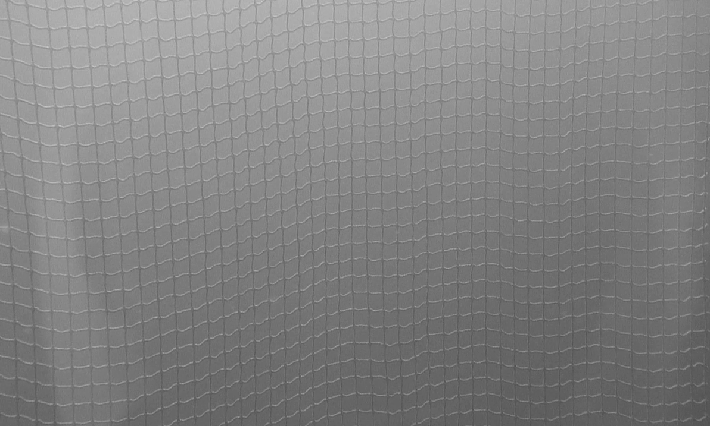 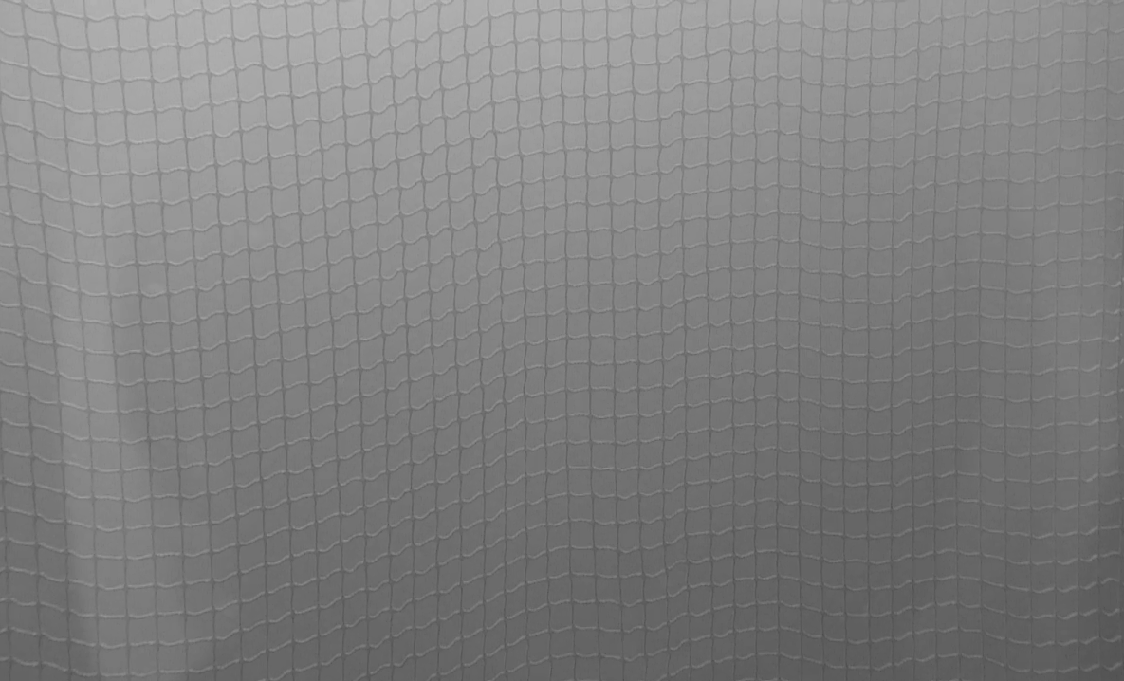

### 

Figure 34: Top-hat kernel size 20

### Contrast enhancement using morphological operations

# Testing and Results

## Test set-up

### Camera

In the testing a FCB-H11 camera from Sony was used (for datasheet see Appendix B – Sony FCB-H11). The camera is controlled via computer software communicating over the serial bus. The computer software is called FCB-HD and is enclosed on the DVD. This camera is the same as the ones used by Argus Remote Systems in their ROVs. Some of its features include:

* Approx. two million effective pixels
* 16:9 aspect ratio
* HD and SD video format
* Day/Night function
* 120x zoom ratio (10x optical and 12x digital zoom)



Figure 35: Sony FCB-H11 camera

### HD-SDI interface module

To combine high quality video transfer with a long range, HD-SDI was chosen as the way to transfer the video signal from the camera. HD-SDI is the common term for a standard named SMPTE 292M (The Society of Motion Picture and Television Engineers). It uses coaxial cables to transport uncompressed digital video and has a range of about 300 meters. HD-SDI is mainly used in TV studios but it is an ideal standard for our use.

To interface the camera an iShot FCB HD-SDI Interface Module from InterTest were used. This interface module acquires digital images directly from the camera in real-time. Instead of re-digitizing the analog output from the camera this module directly connects to the cameras digital output. The datasheet for the iShot can be found in Appendix C – iShot FCB HD-SDI INTERFACE MODULE.



Figure 36: iShot FCB HD-SDI Interface Module

### GigE interface

The iPORT SB-Pro IP engine transforms a Sony FCB-H11 block camera into a GigE Vision® and

GenICamTM compliant camera. The iPORT SB-Pro IP engine transmits high-definition video with low,

predictable latency and has applications in military vetronics, medical imaging, and industrial

inspection systems

The Gigabit Ethernet protocol provides cabling

distances of up to 100m using standard CAT5e/6 cabling; you can incorporate off-the-shelf switches to

provide even further distances. Decreased cable size and increased flexibility are realized when using

Gigabit Ethernet for video transfer .

.

### Frame grabber

To connect the camera to a computer an UltraStudio SDI from Blackmagic Design was used. This unit takes in an SDI signal and passes it to a computer through USB 3.0.



Figure 37: Blackmagic Design UltraStudio SDI

### Camera housing

To withstand being submersed a waterproof camera housing was made by Terje Haugen at the departments mechanical workshop. It consists of a



Figure 38: Camera housing

### Lights

Sufficient lighting is necessary when using computer vision. For our test two 27W LED lights were used. The lights are originally made for lighting up under boats and can be surface-mounted on ship hulls. This design made them well suited for our test. The lights were fastened to independent 2 meter long poles so that they could be moved individually and with a long range during testing.



Figure 39: 27W LED light

### Camera problems

After obtaining the camera and all the components needed to get video on the computer unfortunately the set-up didn’t work. Some tweaking and fixing is expected when connecting together something new but all-in-all it took four weeks to get the system to work properly. The components used were chosen for their plug-and-play ability. In a perfect world the hardware should have worked together when properly connected together, this however is far from a perfect world. When plug-and-play doesn’t work it is really hard to figure out the error source. Combine that with the fact that the UltraStudio SDI doesn’t give any indication of whether it sends video through the USB 3.0 port or even gets viable video in through the SDI port. In addition if the Ultrastudio SDI is connected to the wrong USB 3.0 controller or a controller with old drivers it simply doesn’t work.

After many weeks of rigorous testing we sought the help from Trond Viggo Melum at NRK. Using NRK’s equipment we got to test that every individual piece of hardware worked properly. The error was revealed when trying to get the camera to work. The SDI output from the camera was plugged into Melums laptop via one UltraStudio SDI boxes. However it didn’t work unless we plugged in the combined coax into another UltraStudio SDI box that was hooked up to our laptop. The hardware configuration then looked like in Figure 42. Why the coaxial cable from the combined coax and power cable had to be inserted into the Ultrastudio SDI was a mystery. It turned out that there were ~0Ω between the minus power cord and the shield on the coax. So for the camera to get the required stable power supply the coax shield had to be plugged into something stable. This led to us not getting video even after we switched out the coax from the combined cable because it still was being used to supply power to the camera. After replacing this defect cable with a new coax and running the power together with the serial data through a Cat 5e cable the system worked as it should.



Figure 40: First hardware set-up that worked

### Sea-cage panels

Five panels were made as shown in Figure 43. The idea is to pass the panels one at the time across the camera field of vision and use the developed software to detect the structures in the panels. Either those structures are holes, tears, growth or double sea cage structures. For the growing test a smaller net that simulates growing was attached over the hole of the top left panel in Figure 43 during the growing test. The growing were made to look like *Ectopleura larynx* by tying yarn to the net and letting it go through a few cycles of soaking in water and drying. The end result was close enough for our purposes as can be seen in Figure 44.



Figure 41: Sea cage panels. Top left: Panel with hole. Top middle: Panel with vertical tear. Top right: Panel with double net. Bottom left: Panel with L-tear. Bottom right: Horizontal tear.

 

Figure 42: Ectopleural larynx growth. Actual (Benjaminsen, 2012) (left) and simulated (right)

### Test Rig

The test rig was borrowed from Kevin Frank at Sintef Fiskeri og havbruk. It consists of scaffolding pieces put together so that the net can be moved up and down with a winch and the camera can be placed with various distances from the net, approximately from 1-2 meters.



Figure 43: Test rig

## Field test

The field test was performed in Hommelvik, Sør-Trøndelag, at a port belonging to Malvik Båtforening. The purpose of this field test was to acquire realistic data to test the computer vision system. It was a clear sky and it was very sunny. It fast became evident that the strong sun made our lights unnecessary. With the strong sun we got some troublesome effects in the videos like a vertical light gradient and also reflection of the sunlight on the viewport on the camera housing. During the testing there also blew up quite a strong wind so we got some turbidity in the sea as well. All in all we encountered seemingly realistic environmental conditions during the test.



Figure 44: Field test

During the field test System 1 was tried, however it proved unsuitable to use on the small laptop screen so it didn’t show the video as it should. The system worked fined with the camera, it was just too hard to see the result to be of any real use at that time. Instead the system must be tested with videos recorded during the field test.

The videos taken were captured as raw data and therefore took up a lot of memory. On some videos there are frames missing because the laptop used couldn’t save the frames to disk fast enough. This is something that should be addressed when the test set-up is in use next time. On the enclosed DVD h264 compressed videos are found from the various tests.

## Testing of captured video on System 1

Using the video material obtained during the field test the various functions developed in System 1 were tested to check their viability and usefulness. The functions are described in chapter 4.2.

To the various functions a reference video were used. In this video there is a flawless net that stands relatively still. An image from this video using the L color space is shown in Figure 47

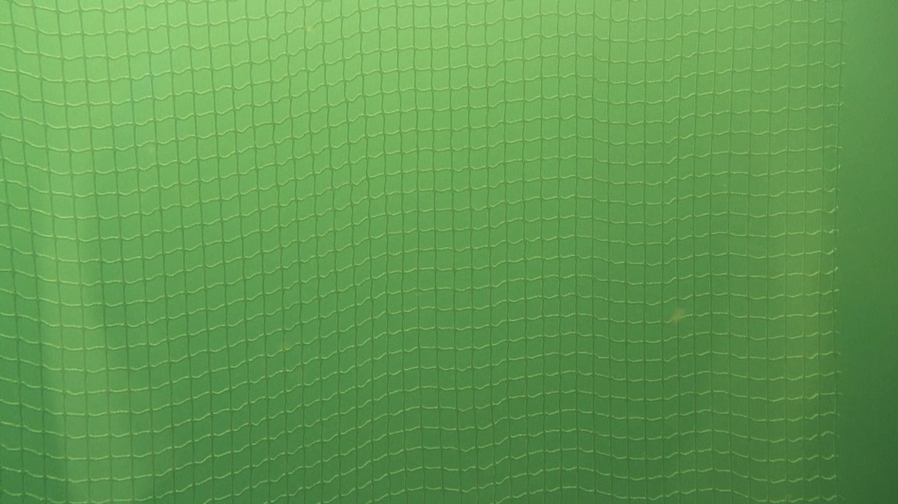 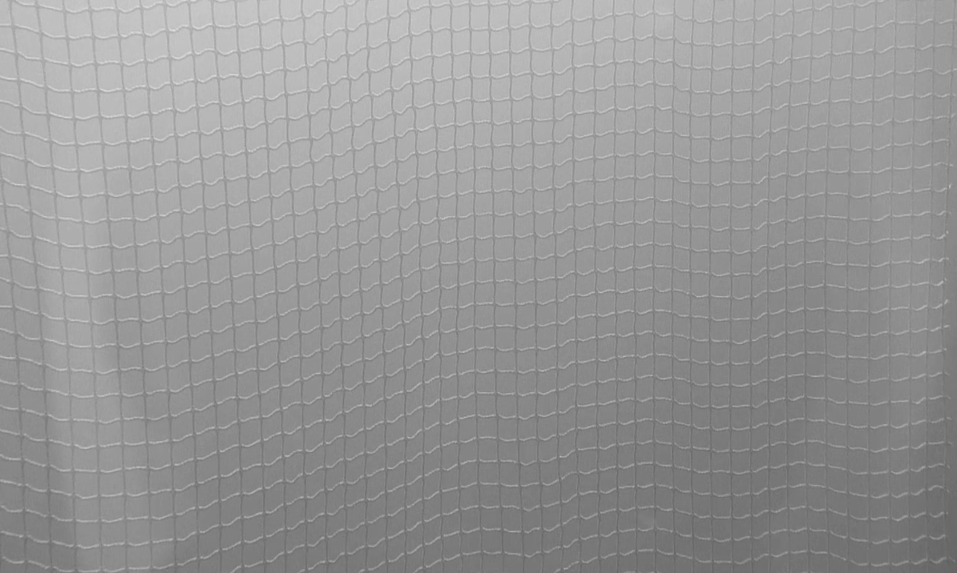

Figure 45: Reference video. Video frame (left)and L color space (right)

The halo of light that is visible on the images in Figure 47 makes the segmentation process harder; the big problem however is in the bottom right of the image. Here the sun isn’t as strongly present as in the rest of the image and combined with the halo it makes the vertical mask parts and the sea to look the same as can be seen in Figure 48. During situations like this it is extremely difficult to determine if the seemingly missing parts of the net is due to damage or just camera issues.

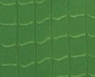 

Figure 46: Bottom right part of the net.

During the testing it became evident that the light from the sun was not as strongly present in the right quarter of the image. This was due to a large boat that was docked in the marina next to the test site. The problems occurring with sub-standard lighting conditions affects the system behavior.

When using there reference video with a moving net problems were encountered. In Figure 51 it can be seen that in the color space image there is no visible horizontal lines in the masks.

 



Figure 47: Scharr segmentation on moving reference net, y color space (left), Scharr segmented image (right) and Otsu segmented (bottom).

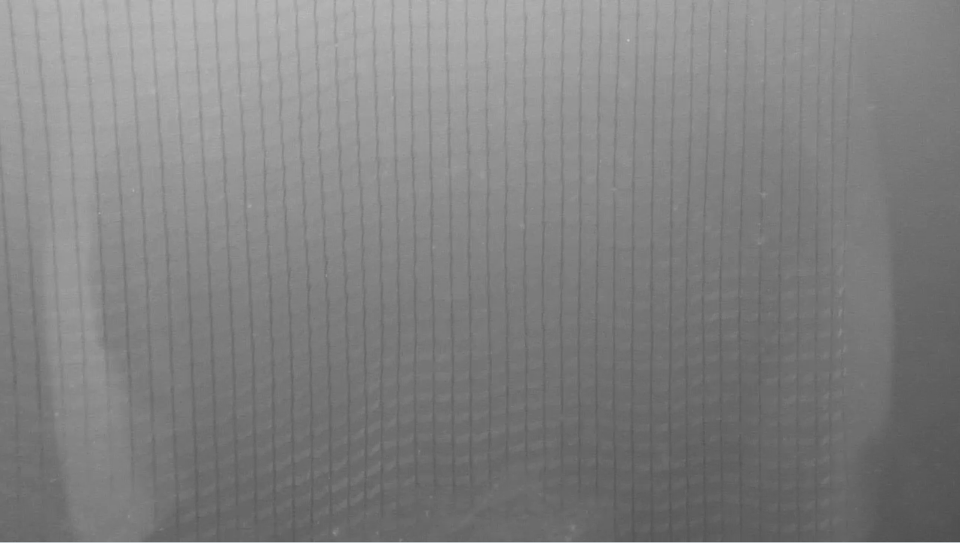

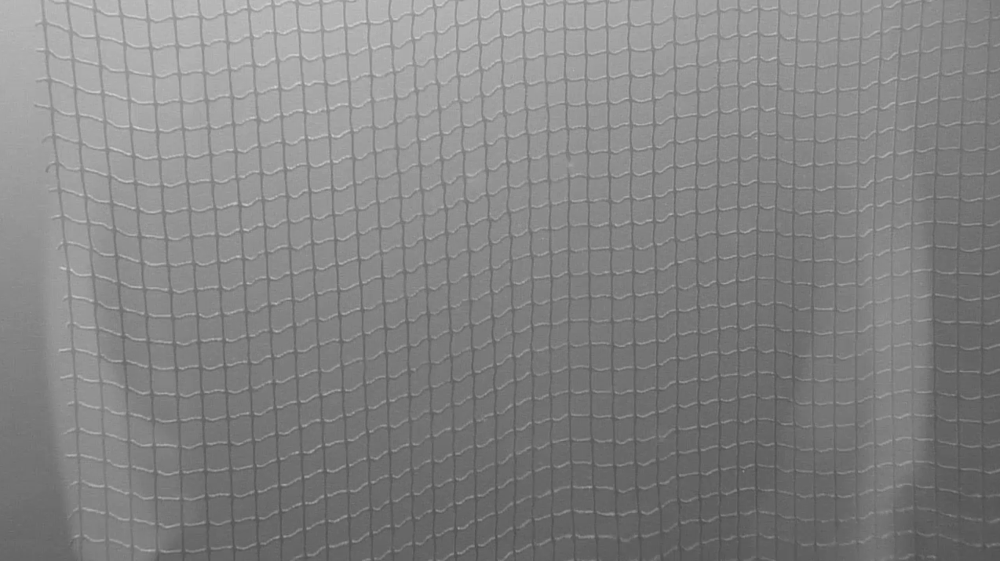

### Color spaces

### Segmentation methods

During the system testing it became evident that edge detection methods performed best with the luminance color spaces. Otsu’s method worked best with the y color space from xyY.

### Using Sobel for segmentation

Using the Sobel segmentation method it became evident that the OpenCV Sobel function didn’t perform as well as was expected. In Figure 47: Reference video. Video frame (left)and L color space (right) the segmentation performed on the reference video and using the L color space it becomes evident that the strong sun reflection on the horizontal part of the sea cage masks makes the OpenCV Sobel function disregard the vertical direction of the masks. When trying to lower the histogram percentile to include more edges the image just gets fuzzy without adding sufficient enough points where the vertical lines are.

 

Figure 48: Using Sobel for segmentation. Histogram percentile = 90 (left) and 70 (right)

Using the detection for enhancing Otsu either doesn’t work properly or have no visible effect on the reference video.

### Using Scharr for segmentation

Using the special Scharr mask in the OpenCV Sobel function led to better results than the Sobel segmentation, Figure 50. When using the Scharr mask the OpenCV Sobel function must first be run in the x-direction then the y-direction the two results was then merged using the OpenCV function Addweighted(). With this function the two results can be weighted when merged together, tuning this variable for varied conditions can increase performance.

 

Figure 49: Using Scharr for segmentation. Histogram percentile = 90 (left) and 70(right)

### Using Otsu’s method for segmentation

Using Otsu’s method did not work especially well with the luminance color spaces. It is very sensitive to the light gradient from the sun and the suns effect on the horizontal lines of the masks. Using the local approach gave a better result. For this method to be viable it must be remade so that when segmenting a sub-image the result must be inverted if the sub-image has defined foreground and background differently than its neighbors.

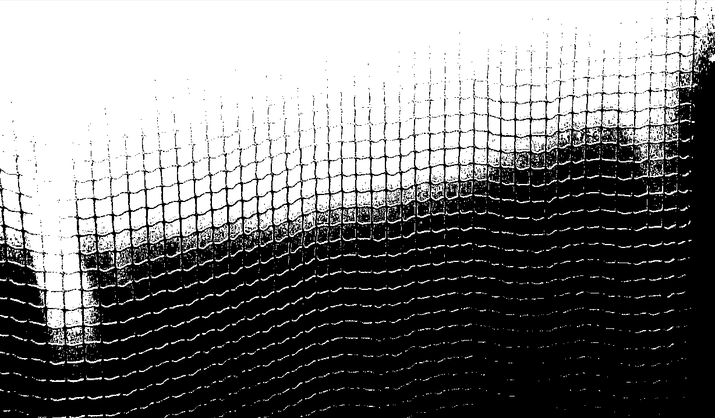 

Figure 50: Using Otsu's method for segmentation, L color space. Global approach (left) and Local approach with 1225 sub-images (right)

When using the chromatic y color space however the results seem more promising. In Figure 52 the local Otsu approach with 1600 sub-images is shown. To see the details only a part of the video frame net is shown. Using the y color space and enhancing the method as explained above may make Local Otsu a viable choice. It uses slightly less computational time compared to global edge detection methods so it would be very interesting to get it to work properly.

 

Figure 51: Using Otsu's method for segmentation, y color space and 1600 sub-images





Figure 52: Reference image, Local Otsu with 1600 sub-images(left), 2116 sub-images (right), 1089 sub-images (bottom)

### Using naïve thresholding for segmentation

Using the naïve approach works up to a point in video frames converted to the y color space. The strong sun still makes too much problems, however at lower depths where sun is not an issue this very simple approach could be used in combination with a master system that adjusts the threshold to get maximal “sea cage structure” in every frame or by manually adjusting it.



Figure 53: Using naive thresholding for segmentation, y color space

### Adaptive thresholding

From 3.2.2 it is stated that the constant C value is deducted from the mean or Gaussian threshold value to optimize the threshold value. Using the reference video with the chromatic y color space it was only possible to use a C value of 1 and 0. Using the L color space instead led to a constant value C of 6 to perform the best and a wider range of C values gave adequate results. In Figure 55 the result from using the y color space is shown. With this approach the segmentation method finds the edges of the net but since it segments both the sea and the net as foreground. This is not desirable since a round of dilation is used when pixels are missing along the borders to close the gaps.

 

Figure 54: Adaptive thresholding with Kernel size of 7 and C set to 1, y color space. Gaussian (left) and Mean (right)

When using the L color space it was possible to segment out the net as solid lines of foreground pixels. In Figure 56 the performance of the region growing algorithm used on the reference video with the L color space is shown. It detects almost all masks expect for some masks in the bottom right

 

Figure 55: Mean adaptive thresholding with Kernel size 7 and C set to 3, L color space

The mean method seems to give stronger segmentation of the net (fatter lines) which makes it easier to get closed contours for each mask. The difference is however not large and both methods could be used.

Typically a constant is deducted from the mean or Gaussian value to optimize the threshold value. This value is typically found empirically.



Mean,Kernel7, C0,ycolor.



 

Gaussian,kernel7,c4,dilation2,Lcolor

### Improvements to be made on System 1

* Improve Sobel segmentation to segment dx and dy separately and then merging. The OpenCV function that performs both at the same time is too sensitive when the light is so strong.
* Improve Scharr and Sobel so that the weights in AddWeighted() can be tuned by the user.
* Improve Local Otsu so that it segments the whole image correctly
* Improve Local Otsu so that if a sub-image appear opposite of its neighbors it inverts the color(i.e. black becomes white and vice versa)
* Remove lightest area color for the region growing algorithm.

## Further motion testing

Legg til no mode på segmentering, I no mode skald et være: input_image.copy2(processed_image)

Sånn blir uprossesert bilde vist uten at man må slette processed! Sweet, men da kan han prøve å kjøre seg på 3kanals, så må endre til hvis(!empty && channel ==1) må også endre vise til label, en for 1kanal og en for 3

As shown in 5.3 the videos recorded during the field testing the horizontal mask lines is blurry during vertical movement. If the shutter speed was too large during capturing the horizontal lines in the masks moved across the frame while the shutter was open. This causes an effect called motion blurring. While motion blurring is an effect often desired to make visual effects in images or to make motion in video games look more realistic it is highly unwanted when the video feed is used in computer vision algorithms.

To avoid the problem of motion blurring one can either develop software algorithms that help reduce the problem, this however takes time to make and have to be used on every frame leading to longer running time for each processed frame. Another way to solve this is to simply decrease the shutter time on the camera, given that the camera can be set to a lower speed. Decreasing the shutter time will make the video feed look less natural and jerkier because there is no visual indicator to how the movement is occurring. This will however lead to better images for the computer vision algorithms.

During the field test the camera was set to “Full Auto” exposure mode, this mode has a fixed shutter speed of 1/50 which has been proven to be too large. However the camera has a total of 21 different shutter speeds available, ranging from 1/2 second to $1/{10000}$ seconds, (Sony, 2008). This gives a wide range of shutter speeds to choose from. However with reduced shutter speed one needs a higher aperture size or stronger lights to get the needed amount of light during the shutters open time. The camera automatically sets iris and gain according to the brightness of the frame, but if that is enough or not have to be tested.

To test what shutter speed is needed to avoid motion blurring the sea cage panels were put up against a wall. The camera was moved while filming the sea cage panel from a distance of 1 meter and 3 meters. First the camera was set to Full Auto which gives a shutter speed of 1/50. Here the motion blurring effects are strong as can be seen in Figure 58.

 



Figure 56: Net filmed with different shutter speed 1/50: 1m distance(top), 3m distance(bottom)

For sporting events or children at play the problem is usually your camera using a film speed that is too slow. Use film with an ISO speed rating of 800 or even 1600.  
  
Read more: [How to avoid motion blur in a picture | eHow](http://www.ehow.com/how_2036673_avoid-motion-blur-picture.html#ixzz2UlfRWAC8) <http://www.ehow.com/how_2036673_avoid-motion-blur-picture.html#ixzz2UlfRWAC8>

### Wikipedia: Measurements and calculations [[edit](https://en.wikipedia.org/w/index.php?title=Film_speed&action=edit&section=22)]

ISO speed ratings of a digital camera are based on the properties of the sensor and the image processing done in the camera, and are expressed in terms of the luminous exposure *H* (in [lux](https://en.wikipedia.org/wiki/Lux) [seconds](https://en.wikipedia.org/wiki/Second)) arriving at the sensor. For a typical camera lens with an effective [focal length](https://en.wikipedia.org/wiki/Focal_length) *f* that is much smaller than the distance between the camera and the photographed scene, *H* is given by



where *L* is the [luminance](https://en.wikipedia.org/wiki/Luminance) of the scene (in [candela](https://en.wikipedia.org/wiki/Candela) per [m](https://en.wikipedia.org/wiki/Metre)²), *t* is the exposure time (in seconds), *N* is the aperture f-number, and



is a factor depending on the [transmittance](https://en.wikipedia.org/wiki/Transmittance) *T* of the lens, the [vignetting](https://en.wikipedia.org/wiki/Vignetting" \o "Vignetting) factor *v*(*θ*), and the angle *θ* relative to the axis of the lens. A typical value is *q* = 0.65, based on *θ* = 10°, *T* = 0.9, and *v* = 0.98.[[60]](https://en.wikipedia.org/wiki/Film_speed#cite_note-ISO-12232_1998-60)

#### Saturation-based speed [[edit](https://en.wikipedia.org/w/index.php?title=Film_speed&action=edit&section=23)]

The *saturation-based speed* is defined as



where  is the maximum possible exposure that does not lead to a clipped or bloomed camera output. Typically, the lower limit of the saturation speed is determined by the sensor itself, but with the [gain](https://en.wikipedia.org/wiki/Gain) of the amplifier between the sensor and the [analog-to-digital converter](https://en.wikipedia.org/wiki/Analog-to-digital_converter), the saturation speed can be increased. The factor 78 is chosen such that exposure settings based on a standard [light meter](https://en.wikipedia.org/wiki/Light_meter) and an 18-percent reflective surface will result in an image with a grey level of 18%/√2 = 12.7% of saturation. The factor √2 indicates that there is half a stop of headroom to deal with [specular reflections](https://en.wikipedia.org/wiki/Specular_reflection) that would appear brighter than a 100% reflecting white surface.[[55]](https://en.wikipedia.org/wiki/Film_speed#cite_note-iso12232-55)

#### Noise-based speed [[edit](https://en.wikipedia.org/w/index.php?title=Film_speed&action=edit&section=24)]

*Main article:*[*Signal to noise ratio (imaging)*](https://en.wikipedia.org/wiki/Signal_to_noise_ratio_(imaging))

The *noise-based speed* is defined as the exposure that will lead to a given [signal-to-noise ratio](https://en.wikipedia.org/wiki/Signal-to-noise_ratio) on individual [pixels](https://en.wikipedia.org/wiki/Pixel). Two ratios are used, the 40:1 ("excellent image quality") and the 10:1 ("acceptable image quality") ratio. These ratios have been subjectively determined based on a resolution of 70 pixels per cm (180 DPI) when viewed at 25 cm (10 inch) distance. The signal-to-noise ratio is defined as the [standard deviation](https://en.wikipedia.org/wiki/Standard_deviation) of a weighted average of the [luminance](https://en.wikipedia.org/wiki/Luminance) and color of individual pixels. The noise-based speed is mostly determined by the properties of the sensor and somewhat affected by the noise in the electronic gain and AD converter.[[55]](https://en.wikipedia.org/wiki/Film_speed#cite_note-iso12232-55)

#### Standard output sensitivity (SOS) [[edit](https://en.wikipedia.org/w/index.php?title=Film_speed&action=edit&section=25)]

In addition to the above speed ratings, the standard also defines the *standard output sensitivity* (SOS), how the exposure is related to the digital pixel values in the output image. It is defined as



where  is the exposure that will lead to values of 118 in 8-bit pixels, which is 18 percent of the saturation value in images encoded as [sRGB](https://en.wikipedia.org/wiki/SRGB" \o "SRGB) or with [gamma](https://en.wikipedia.org/wiki/Gamma_correction) = 2.2.[[55]](https://en.wikipedia.org/wiki/Film_speed#cite_note-iso12232-55)

## Testing of captured video on System 2



Segmented image from system 1, same settings 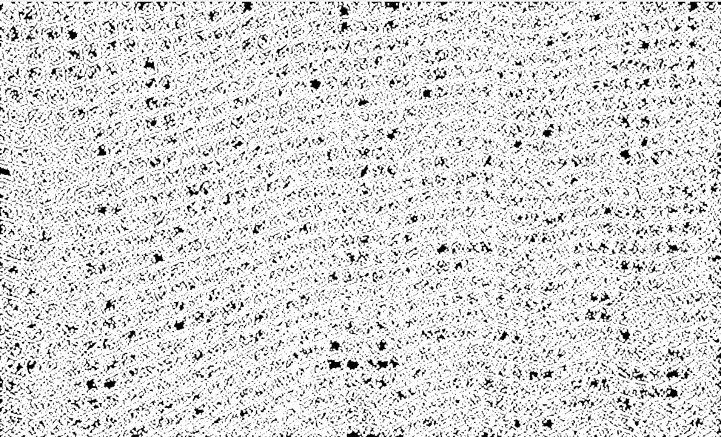



Figure 57: Colorspace: L, Global Sobel, histo percentile 60, kernel size 3, dx=dy=1

### Sea-cage panel with hole

### Sea-cage panel with growth

### Sea-cage panel with vertical tear

### Sea-cage panel with horizontal tear

### Sea-cage panel with L shaped tear

### Sea-cage panel with double netting

# Discussion

# Conclusion

* Skadene vi kan detektere er direkte proporsjonalt med antall masker vi ikke klarer å segmentere riktig, klarer vi å segmentere alle riktig kan vi se så små hull som 2-maske hull
* Kan bruke no fuzzy istedenfor dilation, se om det er noe i nærheten å linke seg til hvis den ikke har en nabo i riktig retninig

# Future work

# Reference list

Akvaplan-niva AS. (2005, June 30). Faktaark 2 Transport og løft av not. *30.06.05*.

Direktoratet for naturforvaltning. (2012, September 17). *Lakselus.* Hentet March 26, 2013 fra miljøstatus.no: http://www.miljostatus.no/Tema/Ferskvann/Laks/Lakselus/

Gonzalez , R., Woods, R., & Eddins, S. (2009). *Digital image processing using MATLAB.* Gatesmark publishing.

Guenther, J., Fitridge, I., & Misimi, E. (2011, October). Potential antifouling strategies for marine finfish aquaculture: the effects of physical and chemical treatments on the settlement and survival of the hydriod Ectopleura larynx. *Biofouling: The Journal of Bioadhesion and Biofilm Research , 27*(9), 1033-1042.

Heide, M. A., & Moe, H. (2004). *Alternative notkonsepter - Delrapport i prosjekt "nye rømningssikre merdkonsepter".* Trondheim: SINTEF Fiskeri og havbruk.

Hoffmann, G. (2013, Januray 31). *docs-hoffmann.de*. Hentet March 18, 2013 fra hoffmann.de: http://docs-hoffmann.de/cielab03022003.pdf

HunterLab. (2008). *Application notes*. Hentet March 18, 2013 fra hunterlab.com: http://www.hunterlab.com/appnotes/an07_96a.pdf

Jensen, Ø., Dempster, T., Thorstad, E., Uglem, I., & Fredheim, A. (2010, August 12). *Escapes of fishes from Norwegian sea-cage aquaculture: causes, consequences and prevention.* Retrieved february 17, 2013, from preventscape.eu: http://preventescape.eu/wp-content/downloads/2010_aei_jensen_et_al.pdf

Kerr, D. A. (2010, March 21). *The CIE XYZ and xyY Color Spaces.* Hentet March 11, 2013 fra http://dougkerr.net: http://dougkerr.net/pumpkin/articles/CIE_XYZ.pdf

Klima- og forurensningsdirektoratet. (2012, April 14). *Rømt oppdrettfisk.* Hentet March 26, 2013 fra miljøstatus: http://www.miljostatus.no/Tema/Hav-og-kyst/Fiskeoppdrett/Romt-oppdrettsfisk/

Laganière, R. (2011). *OPENCV 2 Computer Vision Application Programming Cookbook.* Birmingham: Packt Publishing Ltd.

Paschos, G., & Valavanis, K. P. (1999, February). A Color Texture Based Visual Monitoring System For Automated Surveillance. *IEEE TRANSACTIONS ON SYSTEMS, MAN, AND CYBERNETICS--PARTC: APPLICATIONS AND REVIEWS, 29, NO. 2,*, ss. 298-307.

Rønning, A. (2011, August 20). *Villaks-gener påvirket av oppdrett.* Hentet March 26, 2013 fra forskning.no: http://www.forskning.no/artikler/2011/august/295798

Taylor, M., & Kelly, R. (2010). *Assessment of Protocols and Development of Best Practice Contingency Guidance to Improve Stock Containment of Cage and Land-based Sites Volume 1:Report.* Scottish Aquaculture Research Forum.

# Appendices

## Appendix A – Color space images

### Prototype color spaces

**Original image**



**xyY color space**







**XYZ color space**







**RGB color space**







## Appendix B – Sony FCB-H11





## Appendix C – iShot FCB HD-SDI INTERFACE MODULE













Page 7 is not in the documentation

